 | 

Your Cerebral Palsy Health Check



About this part of the CP Health Checklist
 | This part of the checklist is about you and your health.  It includes questions about health problems that people with cerebral palsy (CP) might have.
  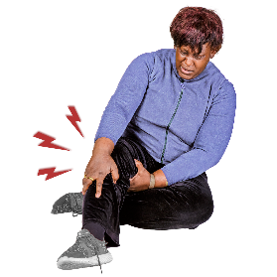  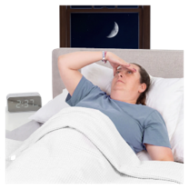     | It covers two topics:  Topic 1: Your pain, sleep, and tiredness  Topic 2: Your other health problems
 | It can help you:  - notice changes  - talk about things that bother you  - know when to ask for help
 | You can use your usual way of communicating.  For example:  - talking  - pictures  - writing  - signs  - augmentative and alternative communication (AAC)
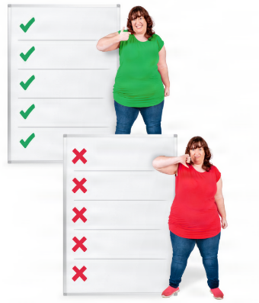 | There are no right or wrong answers.
 | Take your time.  Only answer the questions that are right for you.

What you need to do
 | For each question, tick Yes, No, Sometimes, or I don’t know.  Need help? Tick I want to talk to someone.

Topic 1: My pain, sleep and tiredness
 | Some people with CP have pain.
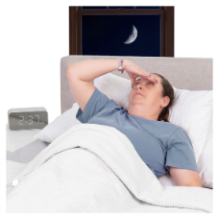 | Some people find it hard to sleep.
 | Some people feel very tired.
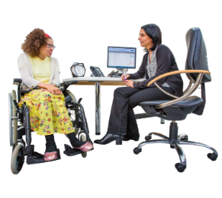 | Talk to your GP if you need help with these problems.
 | These problems can also affect your feelings.  If this is happening, fill in the Your Cerebral Palsy Mental Health Check.

My pain
 | - Are you having any pain?  ☐ Yes  ☐ No  ☐ Sometimes  ☐ I don’t know  ☐ I want to talk to someone
 | - Is your pain getting worse?  ☐ Yes  ☐ No  ☐ Sometimes  ☐ I don’t know  ☐ I want to talk to someone
 | - Where do you have pain?  Put your answer in this box  Write your answer here  It’s ok if you can’t write it down.  Show where you have pain on the picture.

 |  | Did you know?
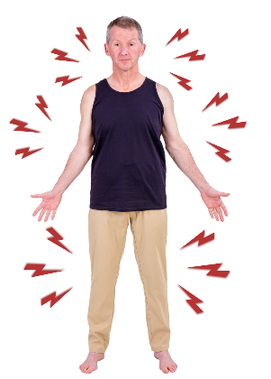 |  |  | Pain can be anywhere in your body.
 |  |  | It can last a short time or a long time.

 |  | Top tip
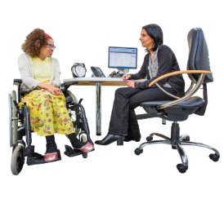 |  |  | Tell your GP:  - where the pain is  - how the pain feels
 |  |  | Learn more about pain on the CP-Pathfinding website

My sleep
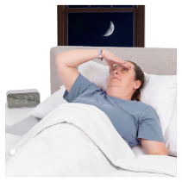 | - Are you having trouble sleeping?  ☐ Yes  ☐ No  ☐ Sometimes  ☐ I don’t know  ☐ I want to talk to someone
   | - Is your sleep different from usual?  ☐ Yes  ☐ No  ☐ Sometimes  ☐ I don’t know  ☐ I want to talk to someone

 | Did you know?
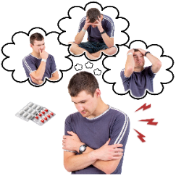 |  | Sleep problems can happen because of:  - pain  - worry  - feeling uncomfortable  - medicines  - other health problems

 | Top tip
 |  | Your GP can help you find ways to sleep better.

My tiredness (fatigue)
 | - Do you still feel tired after resting?  ☐ Yes  ☐ No  ☐ Sometimes  ☐ I don’t know  ☐ I want to talk to someone
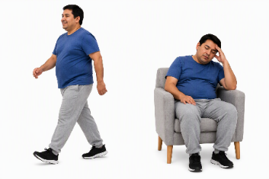 | - Are you more tired than usual?  ☐ Yes  ☐ No  ☐ Sometimes  ☐ I don’t know  ☐ I want to talk to someone

 | Did you know?
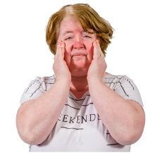 |  | You can feel tired in your body or your mind or both.
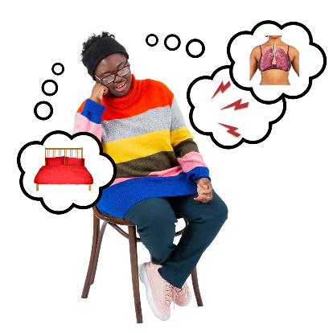 |  | Tiredness can happen for many reasons including:  - pain  - not sleeping well  - breathing problems  - stomach problems

Top tip
Your GP can help find out why you feel tired.

 | How are things going?
 |  | Everything’s OK  Keep doing what works for you
 |  | I’m not sure  Talk to your GP or health professional
 |  | Something has changed  Talk to your GP or health professional
 |  | I’m worried about something  Ask for help

 | Things I want to talk about

 | Write down things you want to talk about with your GP or health professional.  You can write about:  - pain  - sleep  - feeling tired  - things that help you

What is bothering me?
Write your answer here
---------------------------------------------------------------------------------------------------------------------------------------------------------------------------------------------------------------------------------------------------------
--------------------------------------------------------------------------------------------------------------------------------------------------------------------------------------------------------------------------------------------------------------------------------------------------------------------------------------------
-----------------------------------------------------------------------------------
What has changed for me?
Write your answer here
-----------------------------------------------------------------------------------------------------------------------------------------------------------------------------------------------------------------------------------------------------------------------------------------------------------------------------------------------------------------------------------------------------------------------------------------------------------------------------------------------------------------------------------------------------------------------------------------------------
-----------------------------------------------------------------------------------

What do I want my health professional to know?
Write your answer here
-----------------------------------------------------------------------------------------------------------------------------------------------------------------------------------------------------------------------------------------------------------------------------------------------------------------------------------------------------------------------------------------------------------------------------------------------------------------------------------------------------------------------------------------------------------------------------------------------------
-----------------------------------------------------------------------------------

Who do I want to talk to?

 | Tick all the things that apply to you
☐ Talk to my GP |  |   ☐ Talk to another health professional
  ☐ Talk to someone I trust |  |   ☐ I don’t know

Topic 2: My other health issues

My mouth and teeth
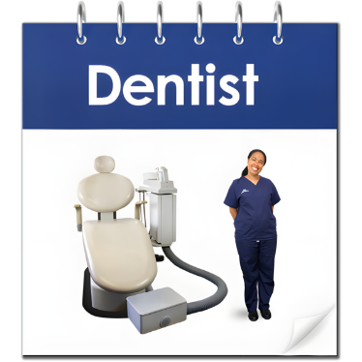 | - When did you last see a dentist?  ☐Less than 1 year ago  ☐1-2 years ago  ☐ More than 2 years ago  ☐ I’m not sure
 | - Does your mouth hurt?  ☐ Yes  ☐ No  ☐ Sometimes  ☐ I don’t know  ☐ I want to talk to someone
 | - Is it hard to chew food?  ☐ Yes  ☐ No  ☐ Sometimes  ☐ I don’t know  ☐ I want to talk to someone

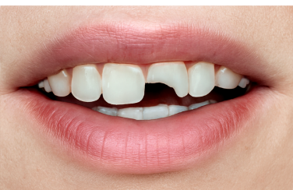 | - Do you have any broken teeth?  ☐ Yes  ☐ No  ☐ Sometimes  ☐ I don’t know  ☐ I want to talk to someone

 |  | Did you know?
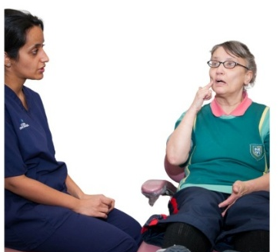 |  |  | People with CP can have more problems with their:  - teeth  - mouth

 |  | Top tip
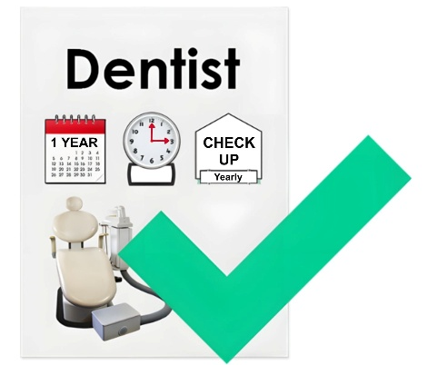 |  |  | Seeing your dentist every year can help keep your teeth and mouth healthy.

My saliva control
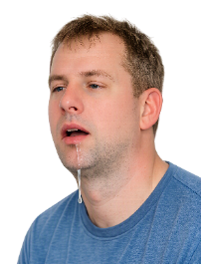 | - Do you have too much saliva?  ☐ Yes  ☐ No  ☐ Sometimes  ☐ I don’t know  ☐ I want to talk to someone
 | - Do you find it hard to control your saliva?  ☐ Yes  ☐ No  ☐ Sometimes  ☐ I don’t know  ☐ I want to talk to someone

 |  | Did you know?
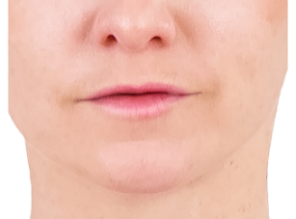 |  |  | Problems with your mouth can change your saliva.
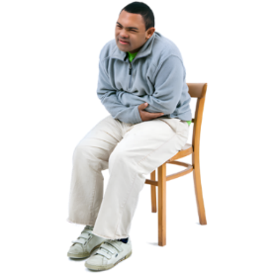 |  |  | Problems with your stomach can change your saliva.
 |  |  | You might:  - have more saliva than usual  - notice a different smell.

 |  | Top tip
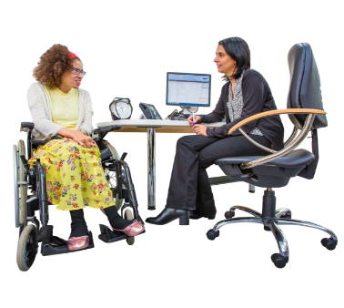 |  |  | Tell your GP if your saliva is different.  Your GP can help with medicines.
 |  |  | A speech pathologist can help with:  - swallowing  - saliva problems

My breathing
 | - Have you had trouble breathing in the last year?  ☐ Yes  ☐ No  ☐ Sometimes  ☐ I don’t know  ☐ I want to talk to someone
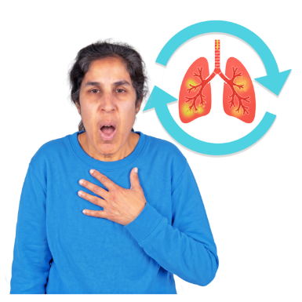 | - Have you been getting chest infections more often?  ☐ Yes  ☐ No  ☐ Sometimes  ☐ I don’t know  ☐ I want to talk to someone
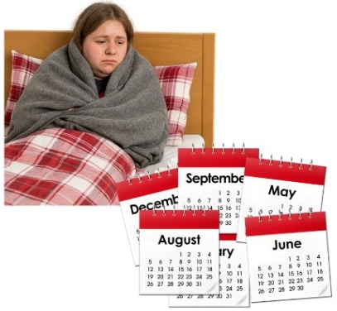 | - Do chest infections take a long time to get better?  ☐ Yes  ☐ No  ☐ Sometimes  ☐ I don’t know  ☐ I want to talk to someone

 |  | Did you know?
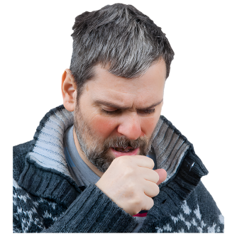 |  |  | People with CP may get chest infections more often.
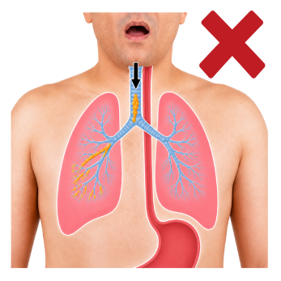 |  |  | Food or drink can sometimes go into your lungs.  This can make you cough or feel sick.

 |  | Top tip
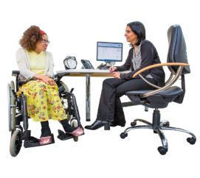 |  |  | Talk to your GP if you have problems with your breathing.

My epilepsy
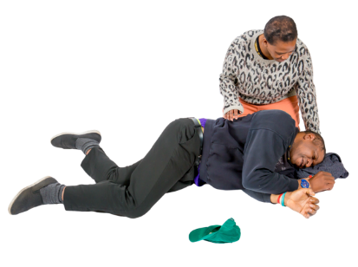 | - Do you have epilepsy?  ☐ Yes  ☐ No  ☐ I don’t know  ☐ I want to talk to someone
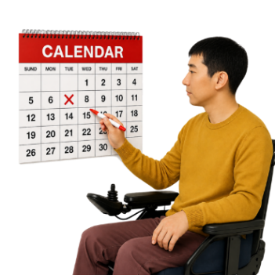 | - If yes, when was your last seizure?  ☐ Last week  ☐ Last month  ☐ Last year  ☐ More than 2 years ago
 | - If you have epilepsy, has a doctor checked your epilepsy medicines in the last 2 years?  ☐ Yes  ☐ No  ☐ I don’t know  ☐ I want to talk to someone

 |  | Did you know?
 |  |  | Epilepsy can change over time.
 |  |  | Your medicine may need to change.  It is good to check your medicine at least every 2 years.

Moving around
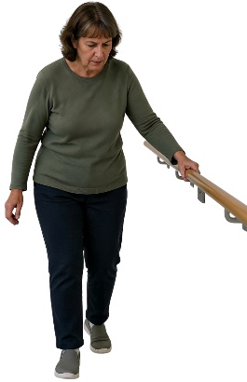 | - Has the way your body moves changed?  ☐ Yes  ☐ No  ☐ Sometimes  ☐ I don’t know  ☐ I want to talk to someone
 | - Do you need more help to walk?  ☐ Yes  ☐ No  ☐ Sometimes  ☐ I don’t know  ☐ I want to talk to someone

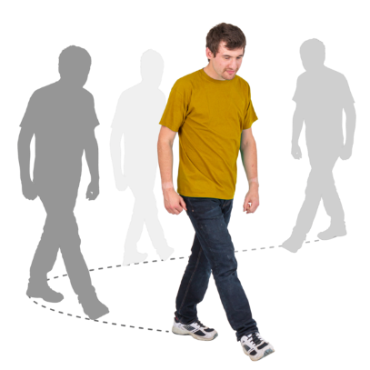 | - Can you walk as far as you used to?  ☐ Yes  ☐ No  ☐ Sometimes  ☐ I don’t know  ☐ I want to talk to someone
 | - Do you have trouble keeping your balance when you walk?  ☐ Yes  ☐ No  ☐ Sometimes  ☐ I don’t know  ☐ I want to talk to someone
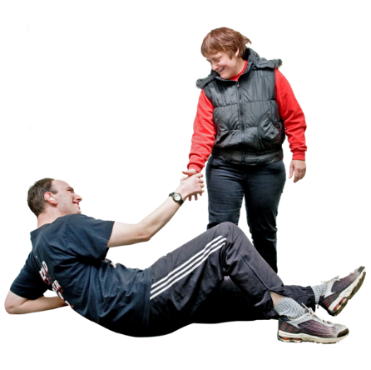 | - Have you fallen in the last 3 months?  ☐ Yes  ☐ No  ☐ I don’t know  ☐ I want to talk to someone

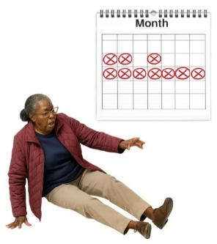 | - Are you falling more than before?  ☐ Yes  ☐ No  ☐ Sometimes  ☐ I don’t know  ☐ I want to talk to someone
- What helps you move around?
 | Tick all the things that apply to you
  ☐ Therapy |  | 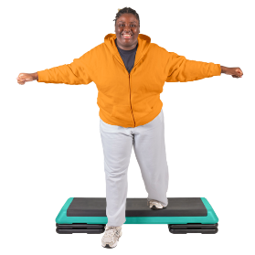  ☐ Exercise
  ☐ Medicine or injections |  | 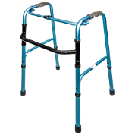  ☐ Equipment like splints, braces, walking aids, wheelchair
 |  |  | ☐ Something else:

Write your answer here

 | - Do you think any of the above need checking?  ☐ Yes  ☐ No  ☐ Sometimes  ☐ I don’t know  ☐ I want to talk to someone

 |  | Did you know?
 |  |  | CP can make it harder to:  - move  - balance
 |  |  | Your muscles may feel:  - tight  - sore

 |  | Top tip
 |  |  | Your GP can check your:  - muscles  - joints
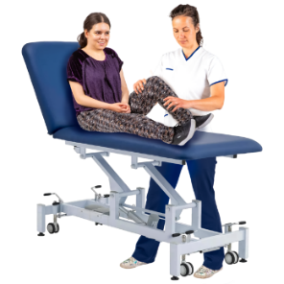 |  |  | A physiotherapist can help you:  - move more easily  - balance better
 |  |  | They can check if a walking aid might help you move safely.

My skin care
 | - Do you have a rash?  ☐ Yes  ☐ No  ☐ Sometimes  ☐ I don’t know  ☐ I want to talk to someone
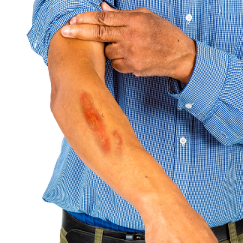 | - Do you have a sore on your skin?  ☐ Yes  ☐ No  ☐ Sometimes  ☐ I don’t know  ☐ I want to talk to someone
 | - Do you have other problems with your skin?
 |  | Write your answer here

My bone health
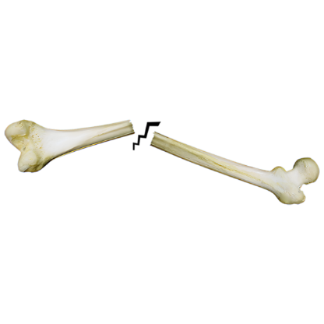 | - Have you ever broken a bone?  ☐ Yes  ☐ No  ☐ I don’t know  ☐ I want to talk to someone
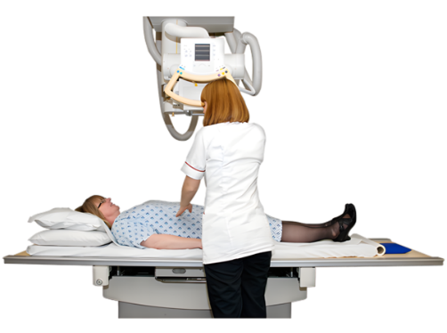 | - Have you had a test to check how strong your bones are?  (this is called a bone scan)  ☐ Yes  ☐ No  ☐ I don’t know  ☐ I want to talk to someone

 |  | Did you know?
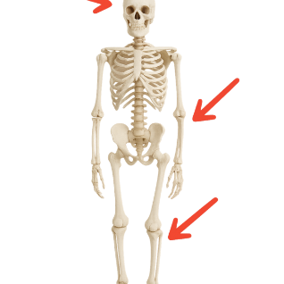 |  |  | Some people with CP can have weaker bones.
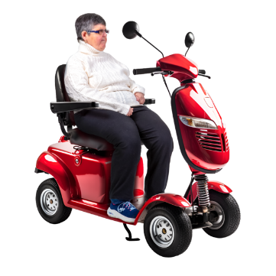 |  |  | This may happen because some people move around less.
 |  |  | Some people may not get enough healthy food for strong bones.
 |  |  | Some medicines can also make bones weaker.

My stomach
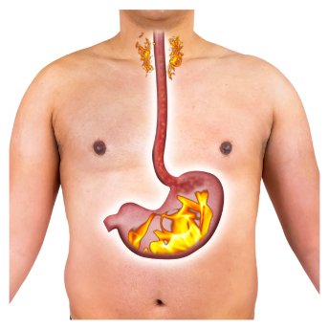 | - Does your chest or throat burn after eating or when you are lying down?  ☐ Yes  ☐ No  ☐ Sometimes  ☐ I don’t know  ☐ I want to talk to someone
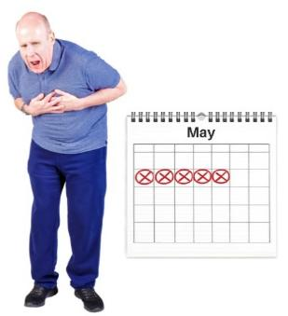 | - Is this happening more often?  ☐ Yes  ☐ No  ☐ Sometimes  ☐ I don’t know  ☐ I want to talk to someone
 | - Do you have stomach pain?  ☐ Yes  ☐ No  ☐ Sometimes  ☐ I don’t know  ☐ I want to talk to someone

 | - Does your stomach feel bigger or tighter than usual?  ☐ Yes  ☐ No  ☐ Sometimes  ☐ I don’t know  ☐ I want to talk to someone

 |  | Did you know?
 |  |  | People with CP can have problems like:  - trouble swallowing  - a burning feeling in the chest or throat  - stomach pain

 |  | Top tip
 |  |  | Your GP can:  - help with these problems.  - help you see a doctor who knows about stomach problems.

Going to the toilet
 | - Do you have problems passing urine (weeing)?  ☐ Yes  ☐ No  ☐ Sometimes  ☐ I don’t know  ☐ I want to talk to someone
 | - Do you have problems passing faeces (pooing)?  ☐ Yes  ☐ No  ☐ Sometimes  ☐ I don’t know  ☐ I want to talk to someone
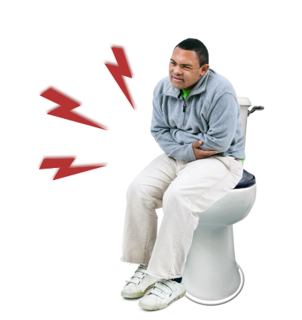 | - Do you have pain when you go to the toilet?  ☐ Yes  ☐ No  ☐ Sometimes  ☐ I don’t know  ☐ I want to talk to someone

 |  | Did you know?
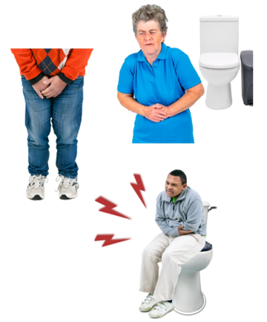 |  |  | People with CP can have problems going to the toilet like:  - accidents  - finding it hard to go to the toilet to do a wee or poo  - pain

 | Top tip
 |  | A GP can help if you have problems going to the toilet.
 |  | A continence nurse can also help you make a plan.

My foot care
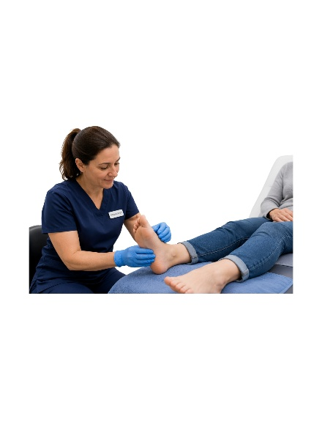   | - Have you seen a podiatrist in the last 6 months?  ☐ Yes  ☐ No  ☐ I don’t know  ☐ I want to talk to someone

 |  | Did you know?
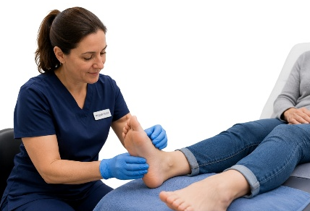 |  |  | A podiatrist can:  - check your feet  - help with foot problems  - help you find shoes that fit  - check your walking and balance

 | Top tip
 |  | Seeing a podiatrist regularly can help keep your feet healthy.

How are things going?
Everything’s OK
Keep doing what works for you
I’m not sure
Talk to your GP or health professional
Something has changed
Talk to your GP or health professional
I’m worried about something
Ask for help

Things I want to talk about

Write down things you want to talk about with your GP or health professional.
You can write about:
- health problems that bother you
- changes in your health
- things that help you
- questions you have

What is bothering me?
Write your answer here
---------------------------------------------------------------------------------------------------------------------------------------------------------------------------------------------------------------------------------------------------------
-----------------------------------------------------------------------------------
What has changed for me?
Write your answer here
--------------------------------------------------------------------------------------------------------------------------------------------------------------------------------------------------------------------------------------------------------------------------------------------------------------------------------------------

What do I want my health professional to know?
Write your answer here
----------------------------------------------------------------------------------------------------------------------------------------------------------------------------------------------------------------------------------------------------------------------------------------------------------------------------------------

Who do I want to talk to?

 | Tick all the things that apply to you
☐ Talk to my GP |  | ☐ Talk to another health professional
☐ Talk to someone I trust |  | ☐ I don’t know
Resource information
Developed by CP-Achieve, Murdoch Children’s Research Institute.
Funded by the National Centre of Excellence in Intellectual Disability Health.
Supported by My CP Guide, Cerebral Palsy Australia.
Photosymbols® Professional Licence: 25733621252472.
Version 1.0 | September 2026.

