 | 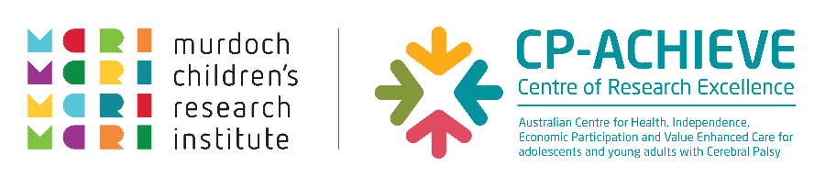

Your Cerebral Palsy Personal Health Check
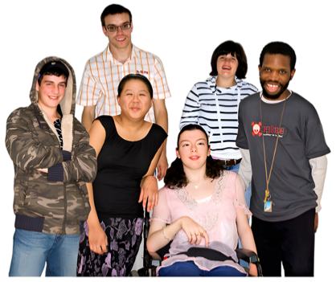


About this part of the CP Health Checklist
 | This part of the checklist is about changes in your body, sexuality, and sexual health.
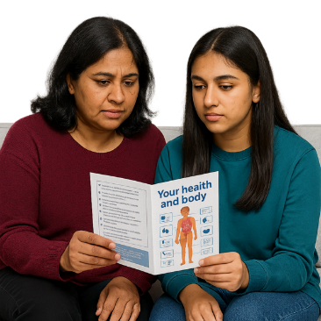 | It covers:  - your body  - relationships  - sex  - gender  - getting older
 | Some questions are for people with:  - women’s bodies  - men’s bodies  Trans and gender-diverse people can use the sections that are right for them.
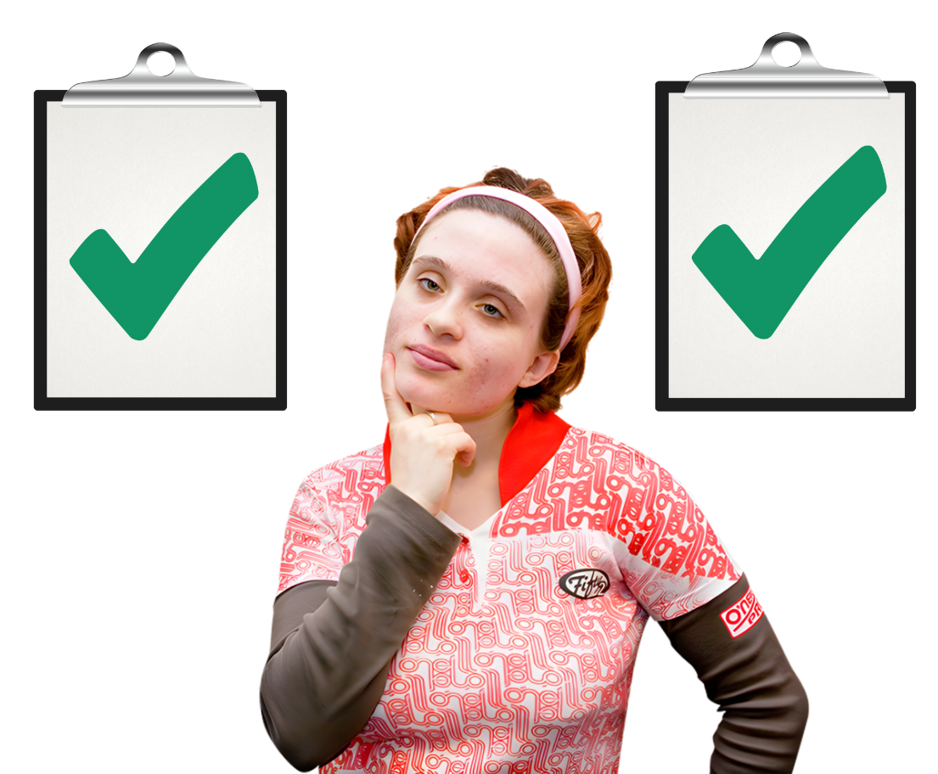 | Choose the information that is right for:  - your body  - your health needs  - your gender identity
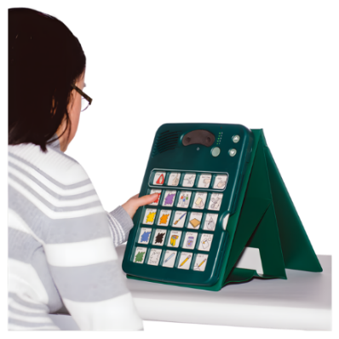 | You can use your usual way of communicating.  For example:  - talking  - pictures  - writing  - signs  - augmentative and alternative communication (AAC)
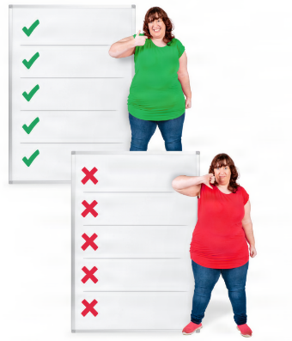 | There are no right or wrong answers.
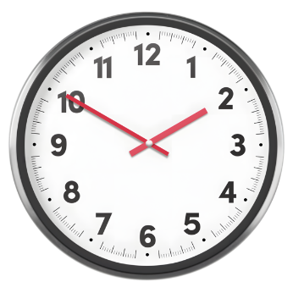 | Take your time.
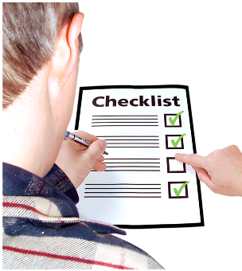 | You do not have to answer questions if you do not want to.
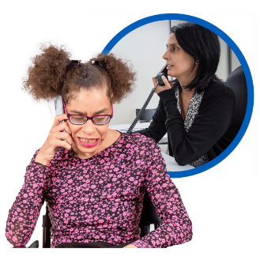 | Talk to your GP if you have questions or worries.
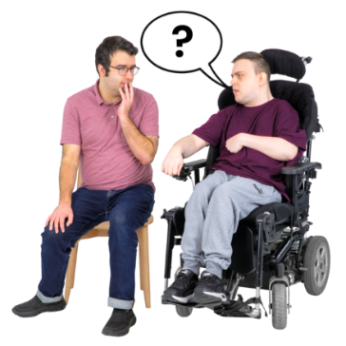 | You can also talk to someone you trust.

What do you need to do?
 | For each question, tick Yes, No, Sometimes, or I don't know.  Need help? Tick I want to talk to someone.

Questions for everybody

Changes in Your Body
 | - Do you have questions about puberty?  ☐ Yes  ☐ No  ☐ Sometimes  ☐ I don’t know  ☐ I want to talk to someone
 | - Are you worried about puberty?  ☐ Yes  ☐ No  ☐ Sometimes  ☐ I don’t know  ☐ I want to talk to someone
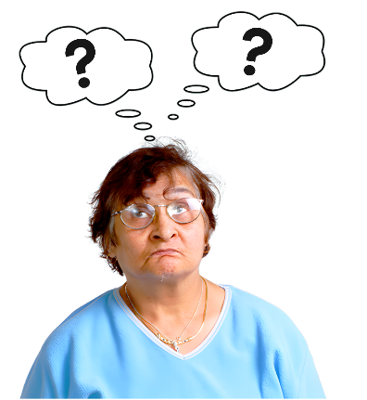 | - Do you have questions about getting older?  ☐ Yes  ☐ No  ☐ Sometimes  ☐ I don’t know  ☐ I want to talk to someone

 |  | Top tip
 |  |  | My CP Guide has information about:  - Sexual health for 18-29  - Sexual health for 30-55+ years

Sexuality and gender
 | - Do you want to talk about who you are attracted to?  ☐ Yes  ☐ No  ☐ Sometimes  ☐ I don’t know  ☐ I want to talk to someone
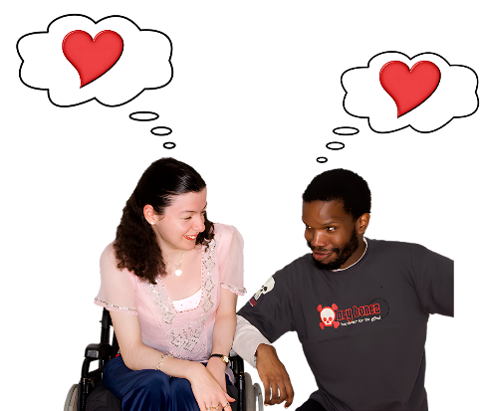 | - Do you want to talk about your sexual feelings?  ☐ Yes  ☐ No  ☐ Sometimes  ☐ I don’t know  ☐ I want to talk to someone
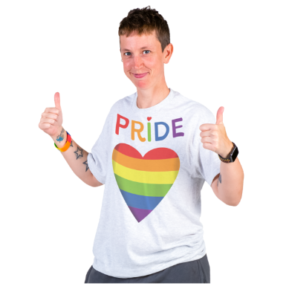 | - Do you want to talk about your gender?  ☐ Yes  ☐ No  ☐ Sometimes  ☐ I don’t know  ☐ I want to talk to someone

Sex and staying safe
 | - Do you have questions about sex?  ☐ Yes  ☐ No  ☐ Sometimes  ☐ I don’t know  ☐ I want to talk to someone
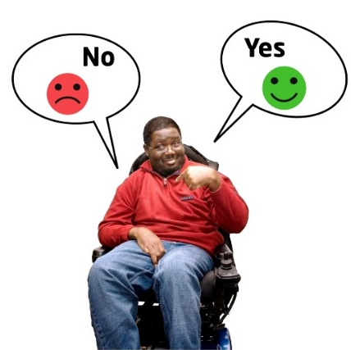 | - Do you have questions about how to say "No" or "Yes" to sex?  ☐ Yes  ☐ No  ☐ Sometimes  ☐ I don’t know  ☐ I want to talk to someone
 | - Do you have questions about staying safe during sex?  ☐ Yes  ☐ No  ☐ Sometimes  ☐ I don’t know  ☐ I want to talk to someone
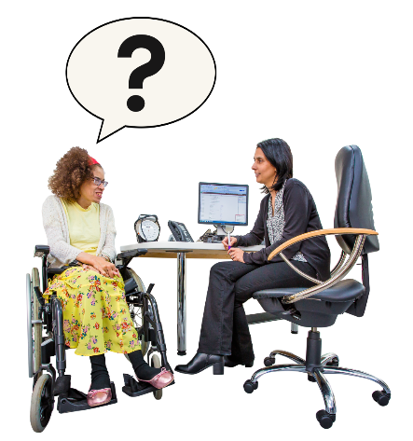 | - Do you have questions about getting infections during sex?  ☐ Yes  ☐ No  ☐ Sometimes  ☐ I don’t know  ☐ I want to talk to someone
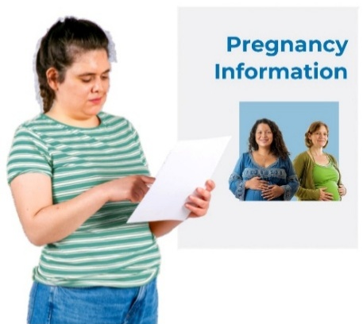 | - Do you have questions about getting pregnant or not getting pregnant?  ☐ Yes  ☐ No  ☐ Sometimes  ☐ I don’t know  ☐ I want to talk to someone

 | Top tip
 |  | It is important to have good information about:  - sex  - relationships  - gender  - your rights
You can learn more on:
- My CP Guide: Sexuality and Gender for People with CP webpage
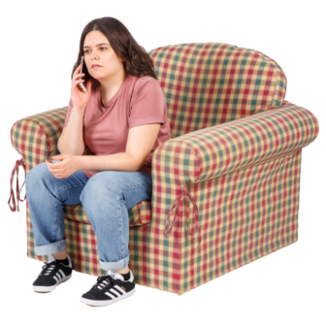 |  | You can also call:  - 1800 My Options  Information about pregnancy, ways to not get pregnant and sexual health.  - QLife  A service for LGBTQ+ people.

Questions for women
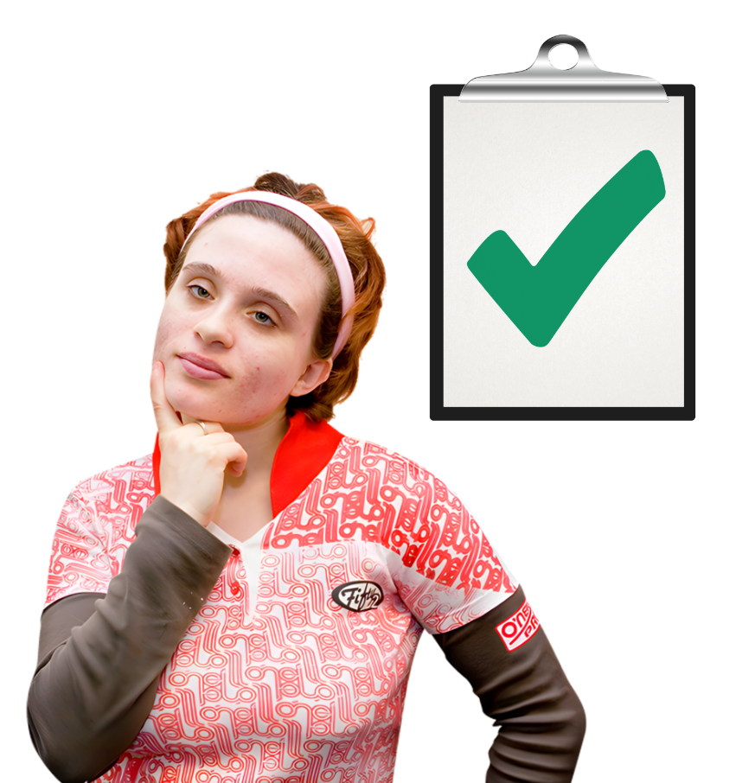 | Choose the information that is right for your body, health needs, and gender identity.

Period Health
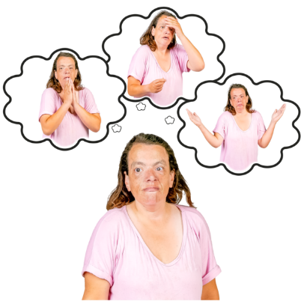 | - Are you worried about your period?  ☐ Yes  ☐ No  ☐ Sometimes  ☐ I don’t know  ☐ I want to talk to someone
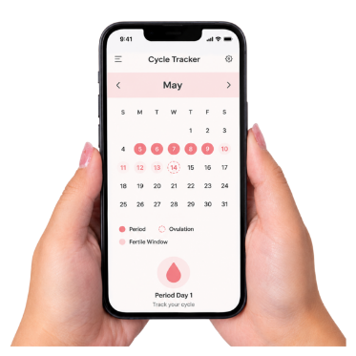 | - Is your period different from usual?  ☐ Yes  ☐ No  ☐ Sometimes  ☐ I don’t know  ☐ I want to talk to someone
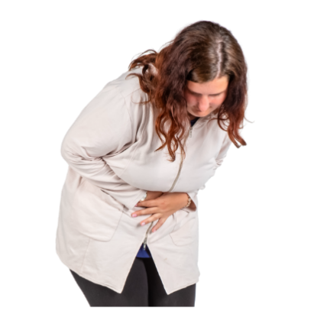 | - Do you have pain during your period?  ☐ Yes  ☐ No  ☐ Sometimes  ☐ I don’t know  ☐ I want to talk to someone
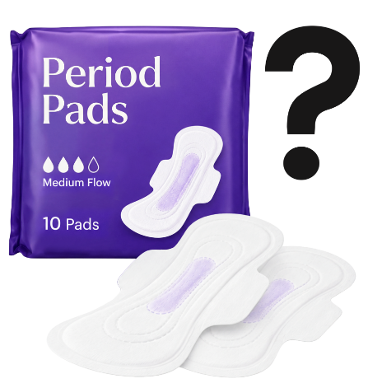 | - Do you have trouble managing your period?  ☐ Yes  ☐ No  ☐ Sometimes  ☐ I don’t know  ☐ I want to talk to someone

Pregnancy
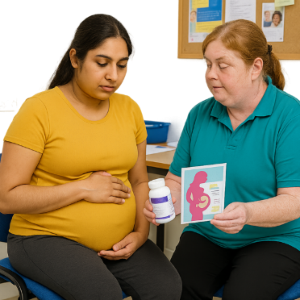 | - Do you have any questions about pregnancy?  ☐ Yes  ☐ No  ☐ Sometimes  ☐ I don’t know  ☐ I want to talk to someone

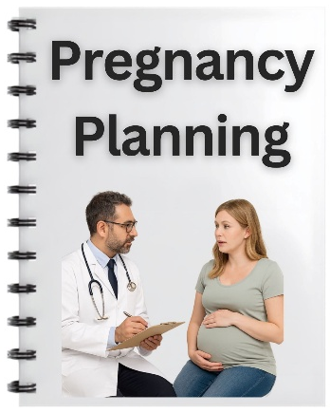 | - Do you have any questions about planning a pregnancy?  ☐ Yes  ☐ No  ☐ Sometimes  ☐ I don’t know  ☐ I want to talk to someone

Menopause
 | - Have your periods changed or stopped?  ☐ Yes  ☐ No  ☐ Sometimes  ☐ I don’t know  ☐ I want to talk to someone
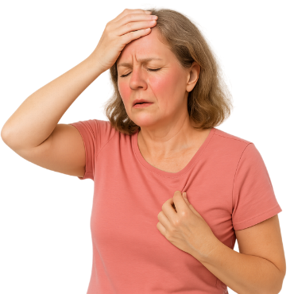 | - Do you get sudden feelings of being very hot (hot flushes)?  ☐ Yes  ☐ No  ☐ Sometimes  ☐ I don’t know  ☐ I want to talk to someone

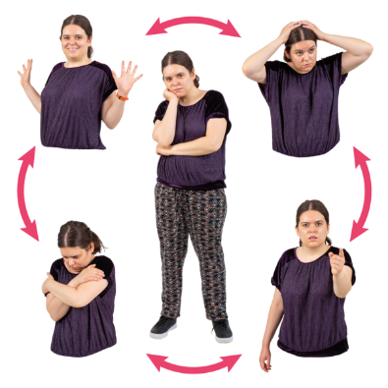 | - Have you had changes in your mood?  ☐ Yes  ☐ No  ☐ Sometimes  ☐ I don’t know  ☐ I want to talk to someone

 | Did you know?
 |  | As women get older, their body makes less estrogen.  Their periods change and then stop.
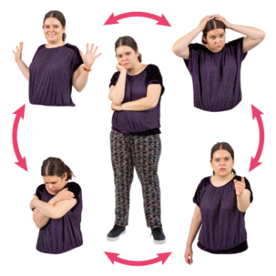 |  | Less estrogen can affect:  - energy  - mood  - sleep
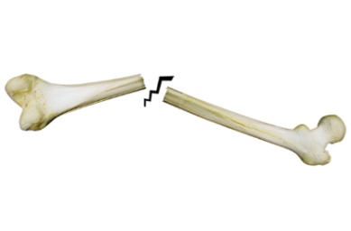 |  | Less estrogen can make bones weaker.  People with CP can have weaker bones.
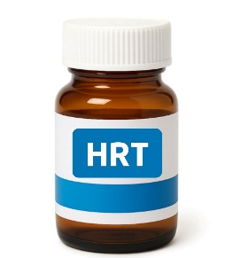 |  | Some people may need a medicine called HRT.  HRT can help keep bones strong.

 | Top tip
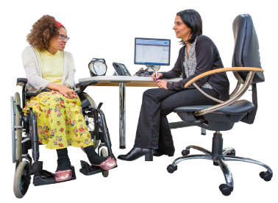 |  | Talk to your GP about HRT for your:  - hot flushes  - mood  - sleep  - bones
You can learn more about women’s health on:
- Council for Intellectual Disability

 | How are things going?
 |  | Everything’s OK  Keep doing what works for you
 |  | I’m not sure  Talk to your GP or health professional
 |  | Something has changed  Talk to your GP or health professional
 |  | I’m worried about something  Ask for help

 | Things I want to talk about

 | Write down things you want to talk about with your GP or health professional.  You can write about:  - your body  - sex  - relationships
What is bothering me?
Write your answer here
---------------------------------------------------------------------------------------------------------------------------------------------------------------------------------------------------------------------------------------------------------
-------------------------------------------------------------------------------------------------------------------------------------------------------------------------------------------------------------------------------------------------------------------------------------------------------------------------------------------------------------------------------------------------------------------------------

What has changed for me?
Write your answer here
----------------------------------------------------------------------------------------------------------------------------------------------------------------------------------------------------------------------------------------------------------------------------------------------------------------------------------------------------------------------------------------------------------------------------------------------------------------------------------------------------------------------------------------------------------------------------------------------------------------------------------------------------------------------------------------

What do I want my health professional to know?
Write your answer here
----------------------------------------------------------------------------------------------------------------------------------------------------------------------------------------------------------------------------------------------------------------------------------------------------------------------------------------------------------------------------------------------------------------------------------------------------------------------------------------------------------------------------------------------------------------------------------------------------------------------------------------------------------------------------------------

Who do I want to talk to?

 | Tick all the things that apply to you
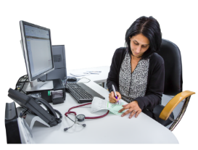  ☐ Talk to my GP |  |   ☐ Talk to another health professional
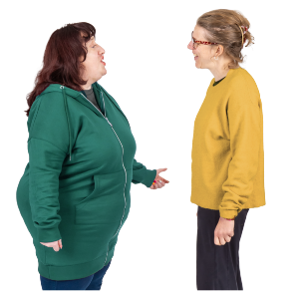  ☐ Talk to someone I trust |  |   ☐ I don’t know

Questions for men
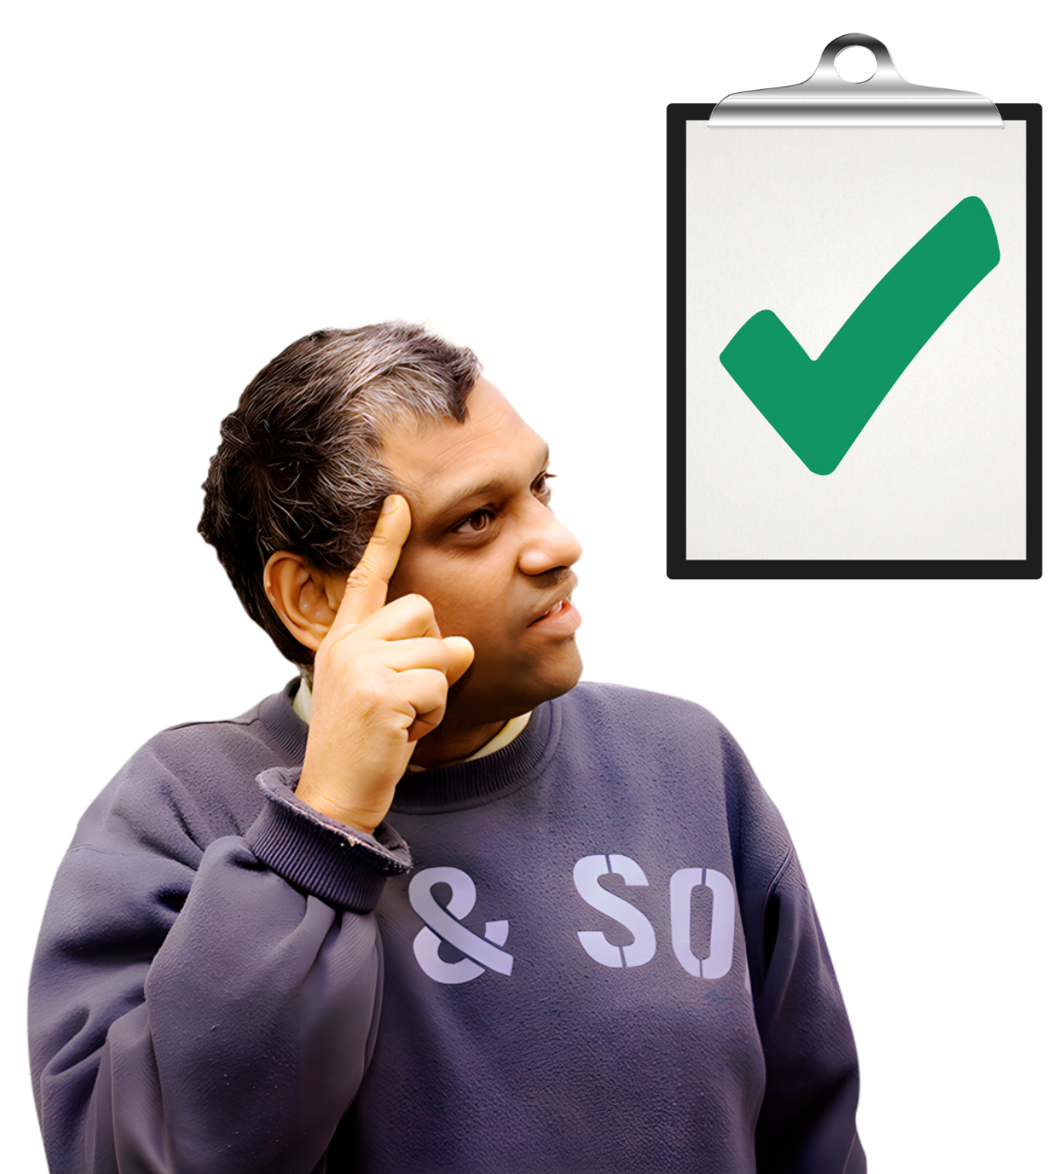 | Choose the information that is right for your body, health needs, and gender identity.

Penis Health
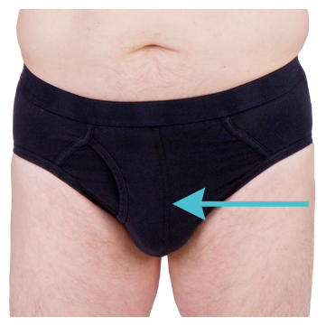 | - Are you worried about your penis?  ☐ Yes  ☐ No  ☐ Sometimes  ☐ I don’t know  ☐ I want to talk to someone

Testicular Health
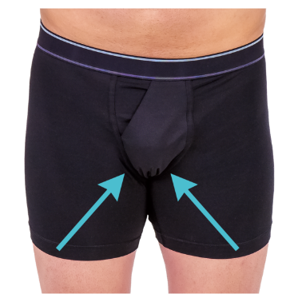 | - Did a doctor tell you that your testicles did not move down when you were a child?  ☐ Yes  ☐ No  ☐ Sometimes  ☐ I don’t know  ☐ I want to talk to someone
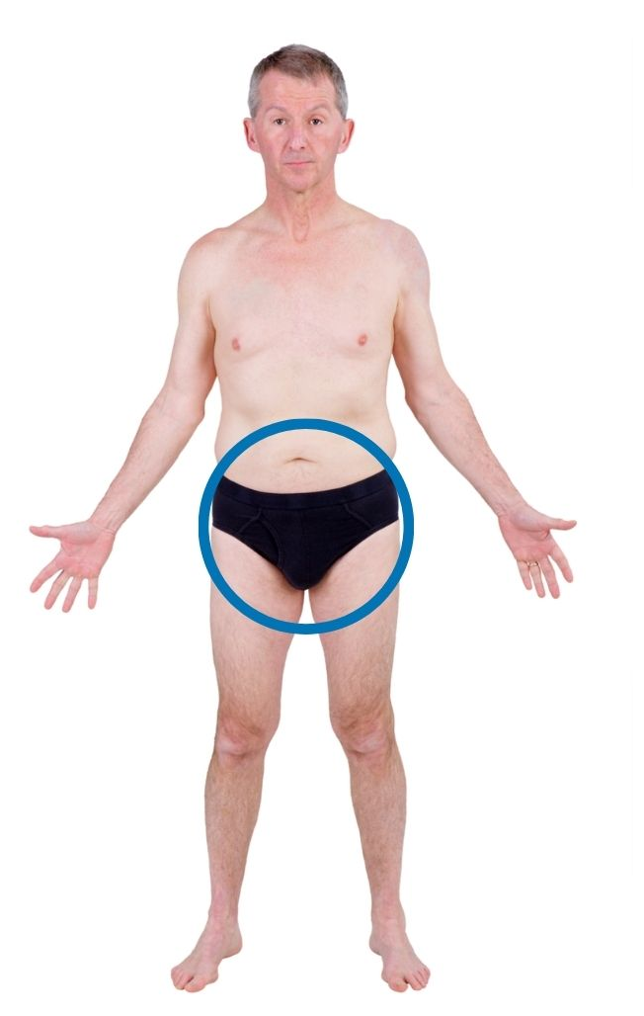 | - Do you have any lumps on your testicles?  ☐ Yes  ☐ No  ☐ Sometimes  ☐ I don’t know  ☐ I want to talk to someone

 |  | Did you know?
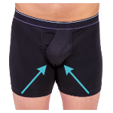 |  |  | Sometimes a person's testicles do not move down when they are a baby.  This can make testicular cancer more likely.

 |  | Top tip
 |  |  | Your GP can:  - check your testicles  - answer your questions

Prostate Health
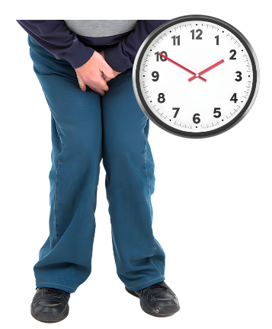 | - Do you need to pass urine (wee) more often than usual?  ☐ Yes  ☐ No  ☐ Sometimes  ☐ I don’t know  ☐ I want to talk to someone
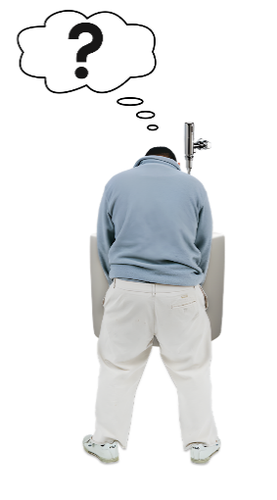 | - Is it hard to start passing urine (wee)?  ☐ Yes  ☐ No  ☐ Sometimes  ☐ I don’t know  ☐ I want to talk to someone
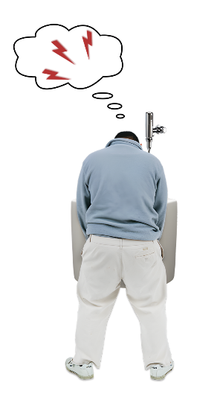 | - Does it hurt when you pass urine (wee)?  ☐ Yes  ☐ No  ☐ Sometimes  ☐ I don’t know  ☐ I want to talk to someone

 |  | Did you know?
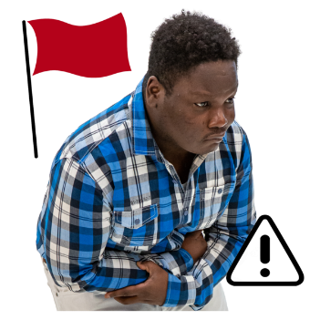 |  |  | Problems passing urine (wee) can happen because of an infection.
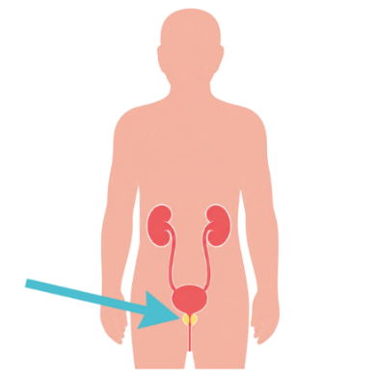 |  |  | They can also happen because of a problem with the prostate.  The prostate helps control how you pass urine (wee).

Top tip
Talk to your GP if you have problems passing urine (wee).

How are things going?
Everything’s OK
Keep doing what works for you
I’m not sure
Talk to your GP or health professional
Something has changed
Talk to your GP or health professional
I’m worried about something
Ask for help

Things I want to talk about

Write down things you want to talk about with your GP or health professional.
You can write about:
- your body
- sex
- relationships
What is bothering me?
Write your answer here
---------------------------------------------------------------------------------------------------------------------------------------------------------------------------------------------------------------------------------------------------------
----------------------------------------------------------------------------------------------------------------------------------------------------------------------
----------------------------------------------------------------------------------------------------------------------------------------------------------------------
----------------------------------------------------------------------------------------------------------------------------------------------------------------------
What has changed for me?
Write your answer here
-------------------------------------------------------------------------------------------------------------------------------------------------------------------------------------------------------------------------------------------------------------------------------------------------------------------------------------------------------------------------------------------------------------------------------
----------------------------------------------------------------------------------------------------------------------------------------------------------------------
----------------------------------------------------------------------------------------------------------------------------------------------------------------------

What do I want my health professional to know?
Write your answer here
-------------------------------------------------------------------------------------------------------------------------------------------------------------------------------------------------------------------------------------------------------------------------------------------------------------------------------------------------------------------------------------------------------------------------------
----------------------------------------------------------------------------------------------------------------------------------------------------------------------
----------------------------------------------------------------------------------------------------------------------------------------------------------------------
Who do I want to talk to?

 | Tick all the things that apply to you
☐ Talk to my GP |  | ☐ Talk to another health professional
☐ Talk to someone I trust |  | ☐ I don’t know
Resource information
Developed by CP-Achieve, Murdoch Children’s Research Institute.
Funded by the National Centre of Excellence in Intellectual Disability Health.
Supported by My CP Guide, Cerebral Palsy Australia.
Photosymbols® Professional Licence: 25733621252472.
Version 1.0 | September 2026.

