 | 

Your Cerebral Palsy Mental Health Check



About this part of the CP Health Checklist
 | This part of the checklist is about your mental health.
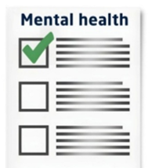 | It covers:  - activities  - feelings  - thinking  - how you act  - worrying thoughts  - talking to someone
 | Mental health problems can happen to anyone.
 | These things can make mental health problems worse:  - pain  - feeling very tired  - trouble sleeping
 | You may already get help for other health problems.
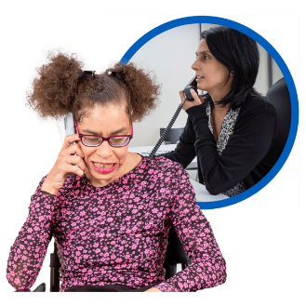 | It is important to talk about your mental health too.
 | You can use your usual way of communicating.  For example:  - talking  - pictures  - writing  - signs  - augmentative and alternative communication (AAC)
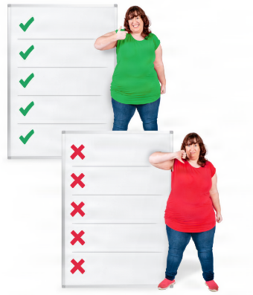 | There are no right or wrong answers.
 | Take your time.
 | Only answer the questions that are right for you.  You do not have to answer questions if you do not want to.
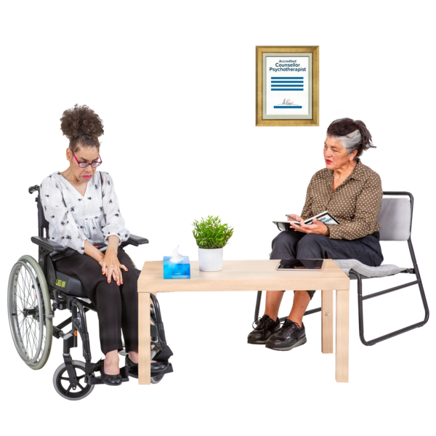 | Talk to your GP about your mental health.  You can also talk to another health professional.

What do you need to do?
 | For each question, tick Yes, No, Sometimes, or I don't know.  Need help? Tick I want to talk to someone.

Activities
 | - Have you stopped enjoying activities you like doing?  ☐ Yes  ☐ No  ☐ Sometimes  ☐ I don’t know  ☐ I want to talk to someone
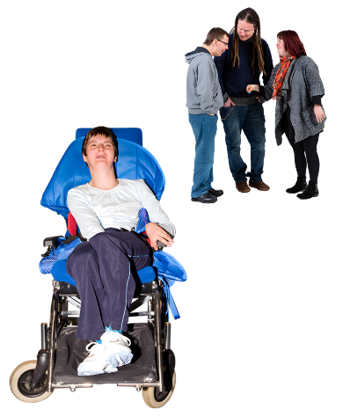 | - Have you been wanting to spend less time with other people?  ☐ Yes  ☐ No  ☐ Sometimes  ☐ I don’t know  ☐ I want to talk to someone

 | Did you know?
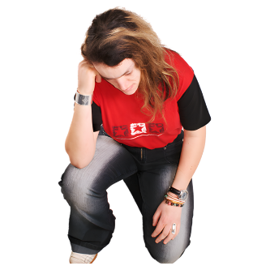 |  | If you feel unhappy, you may spend less time with other people.
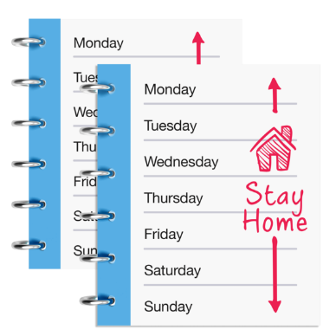 |  | You may stop doing the things you like.  For example:  - seeing friends  - exercising  - going to a day program

Feelings
 | - Have you been feeling sad?  ☐ Yes  ☐ No  ☐ Sometimes  ☐ I don’t know  ☐ I want to talk to someone
 | - Have you been feeling worried?  ☐ Yes  ☐ No  ☐ Sometimes  ☐ I don’t know  ☐ I want to talk to someone
 | - Have you been feeling angry?  ☐ Yes  ☐ No  ☐ Sometimes  ☐ I don’t know  ☐ I want to talk to someone
 | - Have you been feeling confused?  ☐ Yes  ☐ No  ☐ Sometimes  ☐ I don’t know  ☐ I want to talk to someone

 | Did you know?
 |  | You may feel:  - sad  - worried  - confused  - angry

 | Top tip
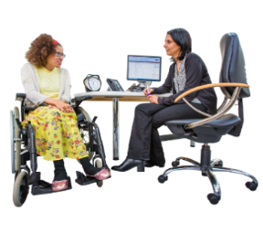 |  | Talk to someone if these feelings continue.  You can talk to:  - your GP  - someone you trust

Thinking
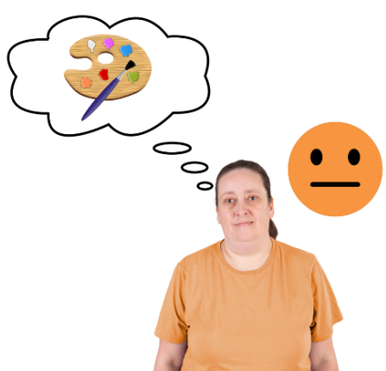 | - Is it hard to stay interested in things?  ☐ Yes  ☐ No  ☐ Sometimes  ☐ I don’t know  ☐ I want to talk to someone
 | - Is it hard to pay attention?  ☐ Yes  ☐ No  ☐ Sometimes  ☐ I don’t know  ☐ I want to talk to someone

 | Did you know?
 |  | Mental health problems can make thinking harder.
 |  | You may find it harder to pay attention to things.
 |  | You may be more forgetful than usual.

How you act
 | - Do you find it hard to sit still?  ☐ Yes  ☐ No  ☐ Sometimes  ☐ I don’t know  ☐ I want to talk to someone
 | - Have you been smiling or laughing less than usual?  ☐ Yes  ☐ No  ☐ Sometimes  ☐ I don’t know  ☐ I want to talk to someone
 | - Have you been eating more or less than usual?  ☐ Yes  ☐ No  ☐ Sometimes  ☐ I don’t know  ☐ I want to talk to someone
 | - Are you sleeping more or less than usual?  ☐ Yes  ☐ No  ☐ Sometimes  ☐ I don’t know  ☐ I want to talk to someone
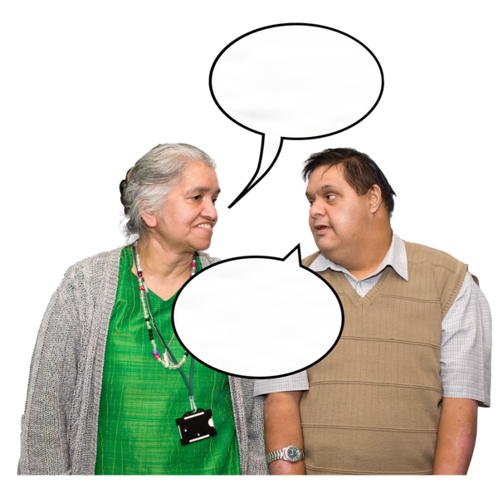 | - Are you talking more or less than usual?  ☐ Yes  ☐ No  ☐ Sometimes  ☐ I don’t know  ☐ I want to talk to someone

 | Did you know?
 |  | Mental health problems can change how we act.
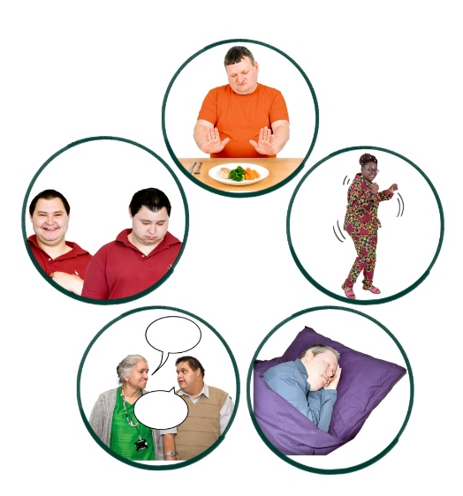 |  | You might:  - eat more or less  - find it hard to sit still  - feel tired  - smile or laugh less  - sleep more or less  - not feel like talking to other people

Worrying thoughts
 | - Have you had thoughts that worry you?  ☐ Yes  ☐ No  ☐ Sometimes  ☐ I don’t know  ☐ I want to talk to someone
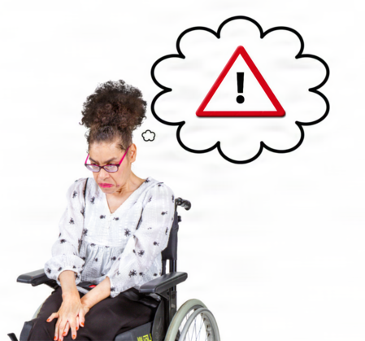 | - Have you had thoughts that make you feel unsafe?  ☐ Yes  ☐ No  ☐ Sometimes  ☐ I don’t know  ☐ I want to talk to someone

 | Did you know?
 |  | Many people have thoughts that worry them.  Many people have thoughts that make them feel unsafe.

Top tip
Talk to your GP.
Talk to a health professional you trust.
They can help you.

Talking to someone
 | - Do you want to talk to someone about your feelings?  ☐ Yes  ☐ No  ☐ Sometimes  ☐ I don’t know  ☐ I want to talk to someone

 |  | Top tip
 |  |  | You can learn more about mental health at:  - Headspace Australia  - MyCP Guide

 |  | Need Help?
 |  |  | These questions may make you feel worried.  These questions may make you feel upset.  Talk to someone you trust.
 |  |  | You can also contact these free services:  - Lifeline: 13 11 14  - QLife: 1800 084 527  - Suicide Call Back Service: 1300 659 467  - Beyond Blue: 1300 224 636  - Kids Helpline (ages 5–25 years): 1800 55 1800
 |  |  | If you are worried, talk to your GP.  You can also go to a walk-in clinic.  If it is an emergency, call 000.

 | How are things going?
 |  | Everything’s OK  Keep doing what works for you
 |  | I’m not sure  Talk to your GP or health professional
 |  | Something has changed  Talk to your GP or health professional
 |  | I’m worried about something  Ask for help

 | Things I want to talk about

 | Write down things you want to talk about with your GP or health professional.  You can write about:  - feelings  - thinking  - how you act  - worrying thoughts
What is bothering me?
Write your answer here
---------------------------------------------------------------------------------------------------------------------------------------------------------------------------------------------------------------------------------------------------------
-----------------------------------------------------------------------------------
---------------------------------------------------------------------------------------------------------------------------------------------------------------------------------------------------------------------------------------------------------
-----------------------------------------------------------------------------------
What has changed for me?
Write your answer here
--------------------------------------------------------------------------------------------------------------------------------------------------------------------------------------------------------------------------------------------------------------------------------------------------------------------------------------------
---------------------------------------------------------------------------------------------------------------------------------------------------------------------------------------------------------------------------------------------------------
-----------------------------------------------------------------------------------
What do I want my health professional to know?
Write your answer here
---------------------------------------------------------------------------------------------------------------------------------------------------------------------------------------------------------------------------------------------------------
--------------------------------------------------------------------------------------------------------------------------------------------------------------------------------------------------------------------------------------------------------------------------------------------------------------------------------------------
-----------------------------------------------------------------------------------
Who do I want to talk to?

 | Tick all the things that apply to you
  ☐ Talk to my GP |  |   ☐ Talk to another health professional
  ☐ Talk to someone I trust |  |   ☐ I don’t know
Resource information
Developed by CP-Achieve, Murdoch Children’s Research Institute.
Funded by the National Centre of Excellence in Intellectual Disability Health.
Supported by My CP Guide, Cerebral Palsy Australia.
Photosymbols® Professional Licence: 25733621252472.
Version 1.0 | September 2026.

