 | 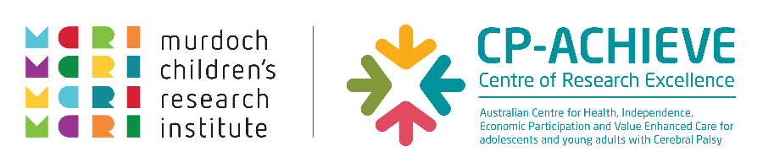

About Your

Cerebral Palsy Health Checklist
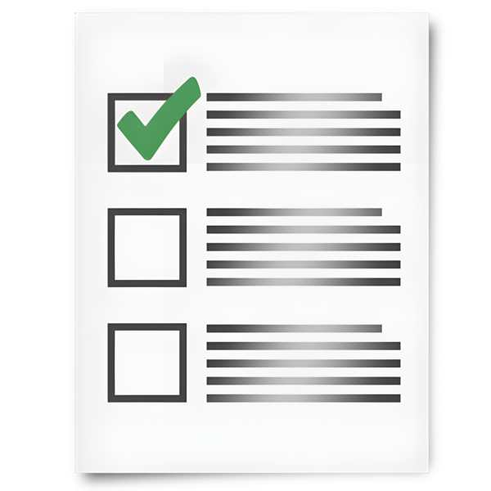
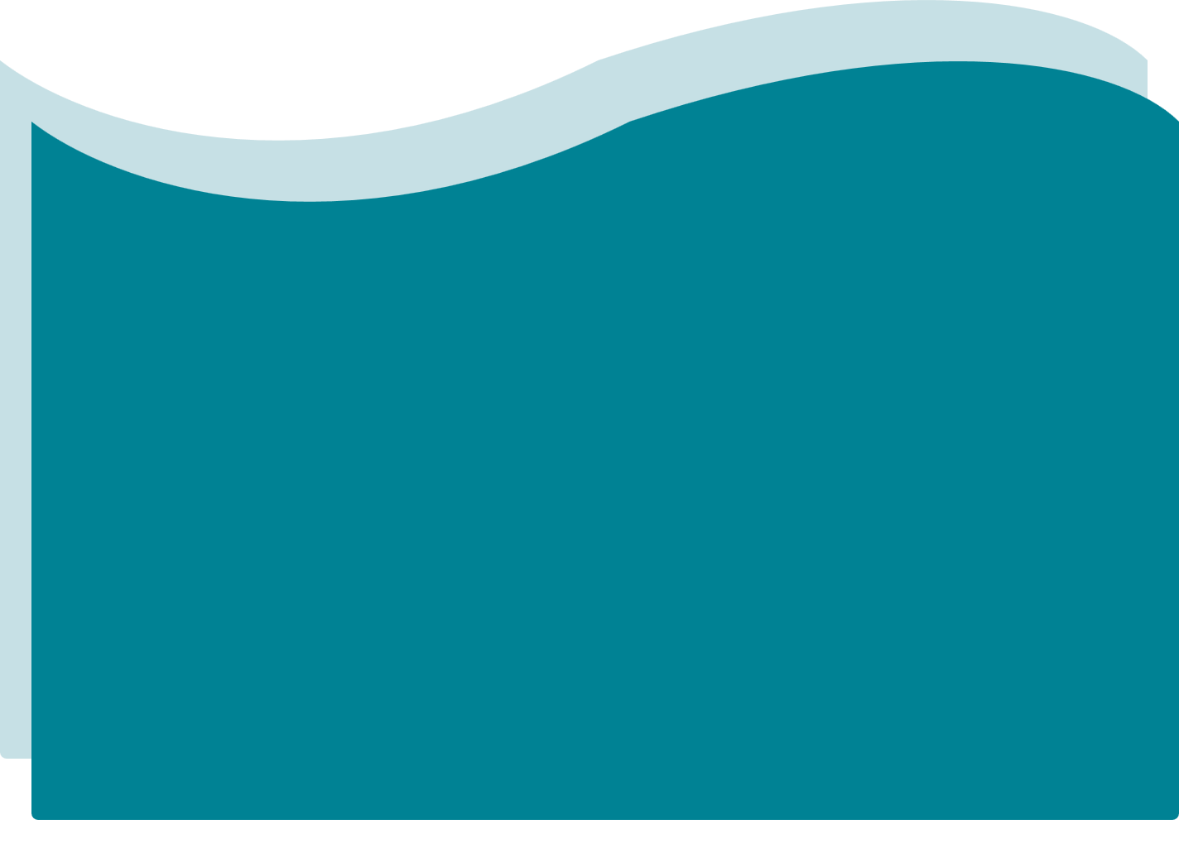

About this checklist
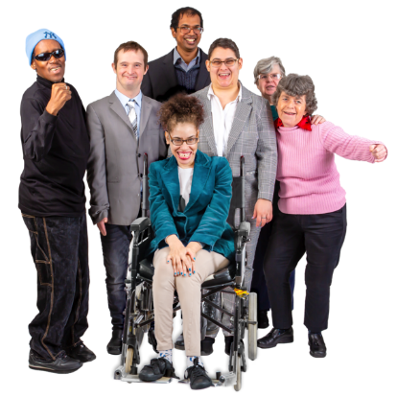 | This checklist is for people with cerebral palsy (CP).
 | It can help you think about your health.
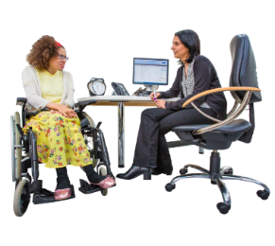 | It can help you talk to your GP and other health professionals.  Other health professionals may include:  - physiotherapists  - speech pathologists  - occupational therapists  - nurses
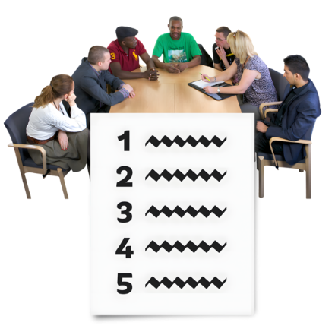 | People with CP and health experts helped create this checklist.
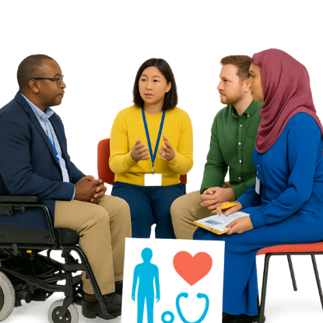 | It includes the health issues that people with CP say are important.

About the different sections
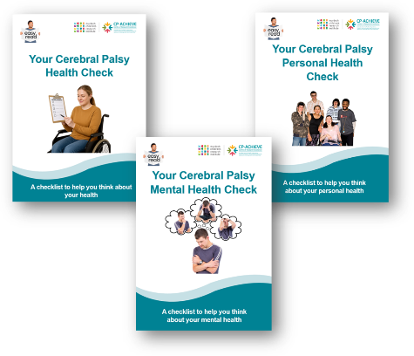 | The checklist is divided into different sections.
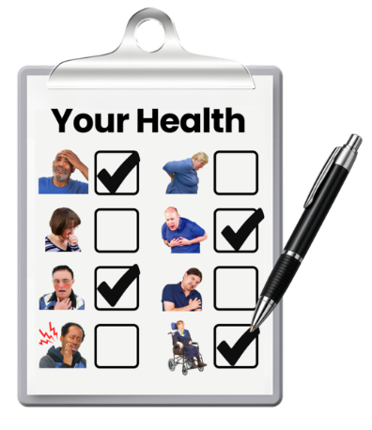 | Each section is about a different part of your health.
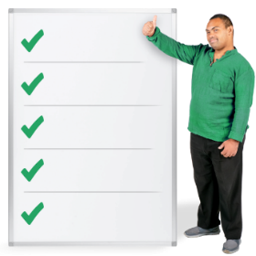 | You can choose the sections that are right for you.

Getting help
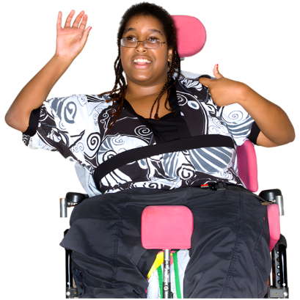 | You can complete this checklist on your own.
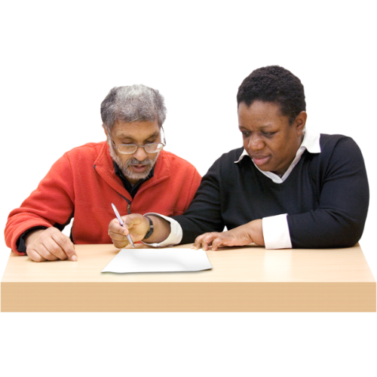 | You can ask someone to help you read, write, or understand the questions.  For example:  - a family member  - a friend  - a support worker  - a health professional

If you have a CHAP
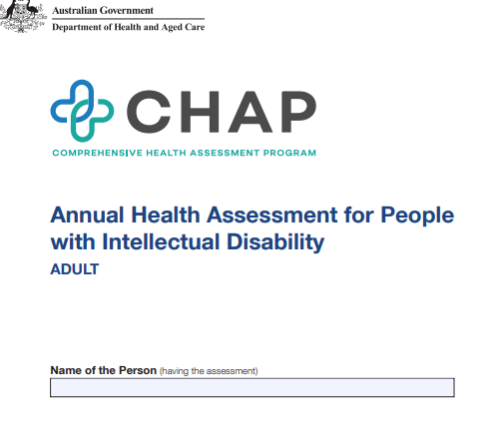 | Some people might have a Comprehensive Health Assessment Program (CHAP).
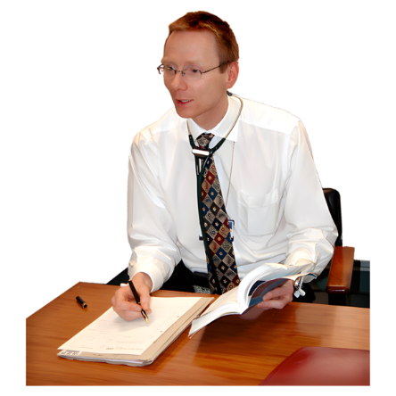 | A CHAP is a yearly health check with your doctor.
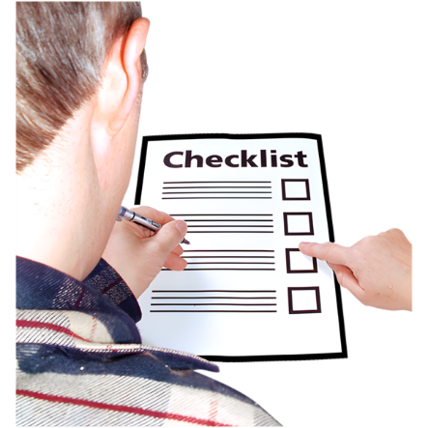 | Some questions in this checklist may also be asked in your CHAP.  This is okay.
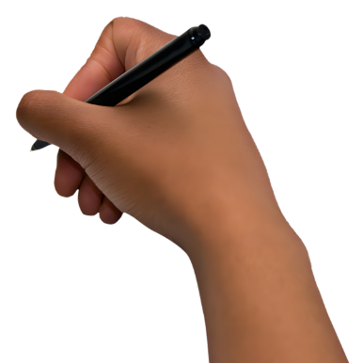 | You only need to answer the questions that are right for you.

Remember
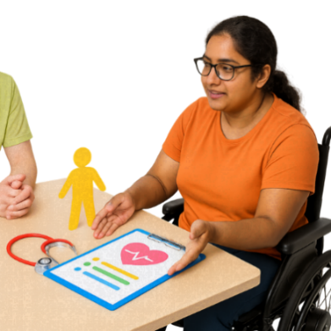 | This checklist is about you and your health.
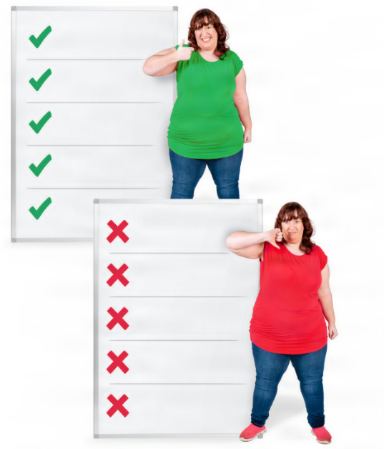 | There are no right or wrong answers.
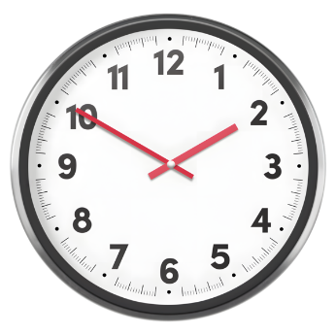 | Take your time.  You can stop and come back later.

Resource information
Developed by CP-Achieve, Murdoch Children’s Research Institute.
Funded by the National Centre of Excellence in Intellectual Disability Health.
Supported by My CP Guide, Cerebral Palsy Australia.
Photosymbols® Professional Licence: 25733621252472.
Version 1.0 | September 2026.

